First Data Set: Flat File

<https://data.baltimorecity.gov/Transportation/Baltimore-Fixed-Speed-Cameras/dz54-2aru>

Second Data Set: Oracle Books

Install the Driver

Download: ODAC1120320_x64.zip to c;\temp

Extract

right click setup.exe > run as administrator

Next

Oracle Data Access Components for Oracle Client

Next

Oracle\Base > C:\oraclexe

Next

Look at the Name **OraClient11g_home1** (or 2 or 3)

Write that value down or copy and paste into Notepad

Next

Available Products (take the defaults no need to change)

Next

Oracle Providers for ASP.NET

Next

Install

End of Installation

Exit

Confirm *.ora files

Browse to C:\oraclexe\product\11.2.0\client_3\Network\Admin\Sample

C:\oraclexe\product\11.2.0\client_3\Network\Admin

Copy 3 files to C:\oraclexe\product\11.2.0\client_3\Network\Admin

listener.ora

sqlnet.ora

tnsnames.ora

Stop Database

Start Database

Control Panel > Small Icons

Administrative Tools

ODBC Data Sources (64-bit)

Select System DSN

Add

Select **OraClient11g_home1** from above

Finish

Data Source Name: MyXe

Description: MyXe

TNS Service Name: XE

User ID: system

Test Connection

password: admin

OK

Connection Successful > OK

OK

OK

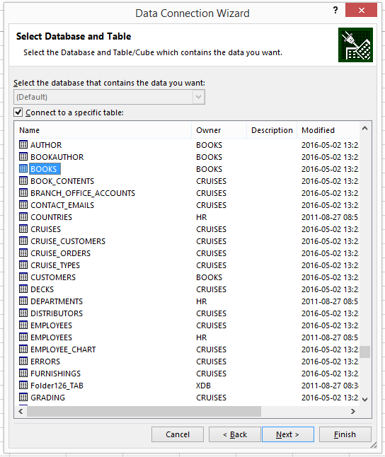

Open Excel

Open Week 1.xlsx

Create a new worksheet

Name it database

Click Data Tab

Get External Data

From Other Sources

From Data Connection Wizard

Other/Advanced

Oracle Provider for OLE DB > Next

1. Specify the Source Name of the Data>Data Source: XE
2. Use a specific user name and password> books\books

Test Connection > Successful > OK

OK

Scroll Down about 90% to the bottom of the list > BOOKS > NEXT > FINISH

Import Data Fialog Box

Leave defaults > OK

Null Password Provided access denied > books

OK

<http://understandinguncertainty.org/coxcombs>

Chrome to view animation

<http://distantyetneversoclose.blogspot.com/2012/01/florence-nightingle-circumplex-chart.html>

Remove Passwords http://www.mcgimpsey.com/excel/removepwords.html

Third Set: Clean Up Data

https://breakingintowallstreet.com/biws/cleaning-up-data-in-excel/

Customer Orders Last 10 years

Problems:

First and Last Name

City not capitalized

Addresses not Capitalized

Names First and Last together

Normalize

<https://people.highline.edu/mgirvin/AllClasses/214_2013/214/Busn214_2013.htm>

=TRIM: Remove extra spaces

=PROPER: Makes first letter in each word uppercase

=CLEAN: Removes all non-printable characters from text

=VALUE: Converts text to number

=TEXT: Converts number or text to new format

Third Set of Data

<https://www.wunderground.com>

Create account

signin

What are my options

Choose cumulus

get key

projectname=wu; company website= mewu

2a23b5150297a8b8 Copy into notepad

Click Documentation>Data Features>Conditions

http://api.wunderground.com/api/2a23b5150297a8b8/conditions/q/CA/San_Francisco.json

http://api.wunderground.com/api/2a23b5150297a8b8/conditions/78729.xml

Exercise Next

Download PowerQuery Addon Excel 2013

Install

Activate

First discover which version of excel File>Account>About Excel

Download Microsoft Power Query

Options>addons>comfirm or add

Power Query Tab

From Web: <http://api.wunderground.com/api/2a23b5150297a8b8/conditions/q/CA/Austin.json>

Home>Advanced Editor

Yelp APi

https://api.yelp.com/v2/business/yelp-san-francisco

oauth_consumer_key

oauth_token